Performance testing for employee data import system
DATE | 07-03-2026
TEAMID | SWTID-2026-2438
PROJECTTITLE | Automating Data import and relationship mapping using import sets&dot walking
MAXIMUMMARKS | 4mark

1.Indroductions
Performance testing is an important part of software development
that evaluates how a system behaves under different workloads. In this
project, performance testing is used to analyze how efficiently the
ServiceNow system handles employee data import and incident assignment
when multiple users access the system simultaneously.
The project focuses on importing employee data from external CSV
files into ServiceNow using Import Sets and Transform Maps. When the
number of records or users increases, the system should still maintain good
response time and stability. Performance testing helps identify whether the
system can handle large volumes of employee data and multiple incident
requests without slowing down.
2. Objective of Performance Testing in the Project
The main objectives of performance testing in this project are:
To test the system performance when importing large employee
datasets.
To measure the response time when users access employee records.
To evaluate system behavior when multiple incidents are created
simultaneously.
To ensure that ServiceNow handles data transformation efficiently.
To identify performance bottlenecks during data import.
3. Performance Testing Scenario
In this project, performance testing is performed under 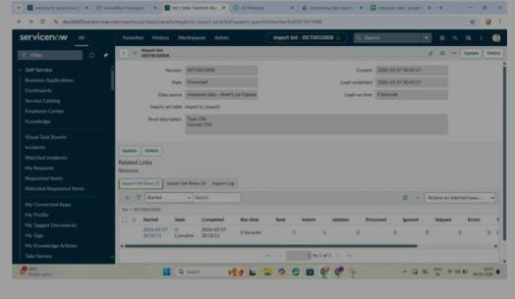

Scenario 1 – Employee Data Import
A large CSV file containing employee information is imported into
ServiceNow. The system should process the data quickly without errors.
followingscenarios.
Scenario 2 – Multiple User Access
Multiple users access the system simultaneously to view employee records
and create incidents.
Scenario 3 – Incident Assignment
Service desk agents assign incidents to employees. The system should
quickly retrieve department and manager details using dot walking.
Scenario 4 – Large Dataset Processing
The system is tested with thousands of employee records to check how well
it handles large datasets.
- Performance Testing Process
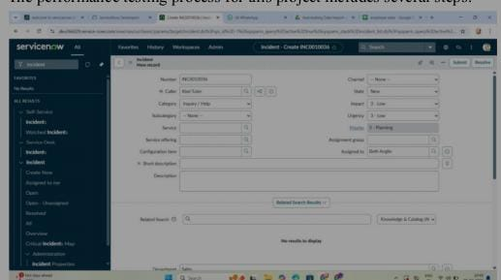
The performance testing process for this project includes several steps.
Step 1 – Test Planning
Define the performance testing objectives, expected number of users, and
the size of the employee dataset.
Step 2 – Test Script Creation
Test scripts are created to simulate user actions such as importing data,
viewing employee records, and creating incidents.
Step 3 – Test Environment Setup
A ServiceNow testing environment is configured to simulate real system
conditions.
Step 4 – Test Execution
Multiple users are simulated to perform actions on
the system simultaneously.
Step 5 – Monitoring
During testing, system performance metrics such as response time, CPU
usage, and database performance are monitored.
Step 6 – Result Analysis
Test results are analyzed to identify slow
operations or system bottlenecks.
5. Performance Metrics Used
The following metrics are used to evaluate system performance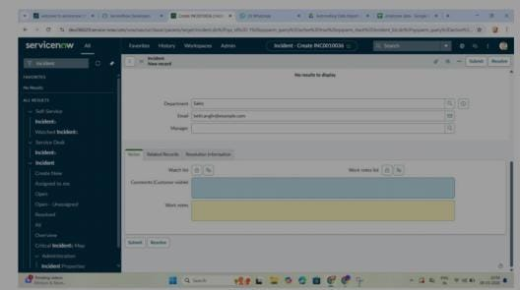
6. Expected Results
After conducting performance testing, the system should:
Import employee data efficiently.
Handle multiple users accessing records simultaneously.
Display related employee information quickly.
Maintain stable performance under heavy workloads.
7. Conclusion
Performance testing ensures that the employee data import system functions efficiently even when large datasets are processed or when many users access the system simultaneously. By analyzing system performance and optimizing the process, the system becomes more reliable and scalable.
+-----------------------+
| Admin / HR System |
| Upload Employee CSV |
+-----------------------+
|
v
+-----------------------+
| ServiceNow Import |
| Set Table |
+-----------------------+
|
v
+-----------------------+
| Transform Map |
| Data Processing |
+-----------------------+
|
v
+-----------------------+
| ServiceNow User |
| Database |
+-----------------------+
|
v
+-----------------------+
| Multiple Users |
| Access Employee Data |
+-----------------------+
|
v
+-----------------------+
| Incident Creation & |
| Dot Walking Fetching |
+-----------------------+
|
v
+-----------------------+
| Performance Metrics |
| Response Time / Load |
+-----------------------+

